Multiple Paths to Success:
Measuring Student Ownership via Reflective Writing on Multi-Path Portfolios
John S. Brewer
Indiana University Southeast

Abstract
This study discusses the interaction between student sense of ownership and multiple path portfolio production in an 11th grade Alternative school ELA classroom setting. The goal of this study is to determine the impact of student choice in curriculum on student sense of ownership, as well as to extrapolate interactions between student engagement data, standardized test success, and attendance on student sense of ownership. The implications of this paper may be of use for other educators interested in Student Centered Learning (SCL) as applied in an Alternative School setting, or educators who consistently engage with students diagnosed with ASD (Autism Spectrum Disorder) or who are diagnosed ODD (Oppositional Defiant Disorder). Future studies involving larger age ranges of students at other Alternative Programs may provide deeper insight into student sense of ownership as it impacts academic and life outcomes.

Problem Statement
A lack of student ownership of curriculum and coursework produces disinterest, low performance, and reduced likelihood of positive outcomes after graduation. Conversely, “Teaching students to become self-determined individuals is an “ultimate goal of education” (Halloran, 1993, p. 214), providing a strong case for increasing student ownership in setting academic goals, monitoring their progress, and self-assessing their performance” (Chan, 2014, p. 3). This study will serve as a measure of current 11th grade student ownership of curriculum and coursework at The Phoenix School of Discovery, with the goal of recognizing and responding to student ownership of academics as these students enter their senior year. “Ownership” in this study is closely linked to the notion of student “agency” in education. Agency can be broken down further into two aspects, “personal integrity,” or, “a respect and appreciation for the unique attributes of the individual,” and “efficacy,” which is when students feel as though their efforts have an effect on their surroundings, “both integrity and efficacy come together to build a sense of agency in which students own a strong perception that they are the key agents of their learning” (Williams, 2017, p. 3).
The study will provide a snapshot of some methods designed to produce student ownership of curriculum. The outcome of the study will be based on student constructed responses, surveys, and will reference past engagement data collected over the course of the year. This study is undertaken with the goal that a unit focused on reflecting on previous student work can increase student sense of ownership of that work, as well as improve student work outcomes during the next year of study.
After working for six years at The Phoenix School of Discovery Alternative Program, I recognize that student ownership of work and educational outcomes is the primary “fight” that I have to engage in to see positive outcomes for students in my classroom. To this end, much of my classroom management, content presentation methods, and engagement tracking system are designed to increase students’ sense of “ownership” of their efforts in my content area.
The roots of student disengagement and lack of ownership are multifaceted and personal to each students’ story. While the problem is complex, there are general experiences that can produce a disaffected attitude towards education and production of writing. Many of our students come from abusive situations and broken homes. Many students are food insecure and take home backpacks of each weekend to make it to Monday. Many students have been moved in and out of state mental health facilities, bisecting years of their schooling before they ever reach our program and denying them a sense of normalcy.
The current political context of this problem can be tied to the charter school initiative currently being pushed in the state of Kentucky at large. The argument goes that programs like Phoenix, programs that attend to individual student needs and innovate with curriculum presentation, are only sustainable outside of the public-school system. This is obviously fallacious, as Phoenix exists and innovates well within existing budgetary structures that JCPS already has in place. The continued (going on 15 years) existence of Phoenix is a testament to the district’s commitment to trying new methods of content presentation, new ways to improve student engagement and decrease truancy in the at-risk population that Alternative Schools serve.
Politically, this unfortunately makes Phoenix a useful lever for both positive and negative educational narratives about Public Education at large. While Phoenix is innovative instructionally, structurally, and in its program goals; Phoenix services a population that experiences success tenuously without support structures, and who are fragile both academically and emotionally. The structure and goals of Phoenix educators are a prime positive example of “charter school style” methods, and the state assessment scores produced by Phoenix are a generally negative example of classic alternative school problems with academic retention, test anxiety, and low performance on standardized assessments designed with college access in mind (ACT, SAT, MAP, KPREP etc.).
The policy issues that affect student ownership of curriculum at Phoenix are primarily those of student placement and class size. Our program has an average “student : teacher” ratio of 20:1, which is slightly higher in English and Social studies due to the 50% ECE population and the requisite higher co-teaching needs for those courses. By moving our program to the smaller building at Jaeger Education Facility in St. Mathew next year (previously Jaeger Elementary) we are being given a “soft” mandate that keeps our class size low. I personally will be moving into what used to be the 3rd floor teacher’s lounge to teach my classes, and this space constraint should (hopefully) keep our class sizes in a place where individualized student content pathing and portfolio production are still viable as they are in our current location at the Mary P. Myers building in the Buechel neighborhood of Louisville.
The cultural context of student ownership is primarily one of parent disengagement with education. Most of our parents are non-college graduates, and many students will be the first high-school graduates in their close family when they walk at graduation. Because the public-school system has historically failed their parents, a sense of importance in education is often lost when Phoenix parents raise children of their own.
While Phoenix is centrally located within JCPS, (less so next year, when we are being moved further to the East side which will pose a difficult transportation problem for our students from the west side of Louisville) Phoenix services students from every zip code in JCPS due to its mandate as an “A-5” safety net school. However, the majority of our students hail from west of Interstate 65 (a historically relevant landmark that has divided in the past, and continues to divide today, the city racially and economically (Equity, 2013, p. 3). Because most of our students are “west of 65” we inherit some of the problems that those neighborhoods experience (drug usage and selling, unemployed and homeless families, gang affiliation, etc). The socio-economic experience of students is one of the factors that lowers their sense of the importance of getting an education as a means to be employed. I’ve had students drop out to become more active in gang activities, to be stay-at-home parents when they chose not to attend the TAPP program for young mothers, and for other medical or mental health reasons due to the stress of living in a higher crime area of the city.
Phoenix is a program that is full of teachers dedicated to providing a caring and personalized academic experience to students. Our faculty has presented its different methods of classroom “gamification” at GenCon Trade Day on two occasions and has presented PD around JCPS on many other occasions, and in the 2018-19 school year, we will be partnering with Summit Learning to further increase the specificity of student interventions. Summit contains a myriad of new and carefully designed rubrics to expand our already large collection of alternative measures for skill acquisition and mastery. Our school excels at providing many pathways to success for our students. This emphasis on personalization is in direct response to the apathy and disconnection that many of our students feel toward their work and the school system at large.
The classroom context of this study is one that has been molded over the past few years to respond to student apathy, students with ASD, and students who are Defiant. The primary educational philosophies driving the classroom structure are the anti-banking model writings of Paulo Freire.

Review of Research Literature
The research discussions surrounding student agency in curriculum production and completion are diverse and fascinating. The definition of agency itself is a hotly debated topic with a long history of appropriation and distortion. The notion of Student Agency in this study is interchangeable with Authorial Agency in the 2015 article, Mapping Concepts of Agency in Educational Contexts. In the article, Authorial Agency is described as,
“Authorial agency focuses on the production of culture, which is the individual’s unique culture making activity on both larger, more recognizable, and smaller, less recognizable, scales. Osberg and Biesta (2010) suggest schools ought not seek to enculturate student subjectivities in any preset mode (i.e., reproduction of culture) but to aid students in defining and empowering their agency to be unique as individuals. Underlying the notion of uniqueness has often been a recognition that it can lead to innovation and the potential for societal change. (Matusov, 2015, p. 15)
This highly technical paper discusses the different kinds of agency that a person can be described as having. While the bulk of the paper is spent discussing the four kinds of agency the authors arrive at “Instrumental, Effortful, Dynamically emergent, and Authorial” the paper does produce a suggestion that students’ Authorial Agency should be cultivated as much as possible with the goal of student self-determination and success as a self-directed individual. The paper quotes Rousseau as a pioneer who recognized the importance of perceived student agency, “let him [the student –the authors] always think he is master while you are really master (Matusov, 2015, p. 21).
With student agency and the perception of control as primary course goals, there are many different methods and tools an educational researcher can tap. The “Key Project” structure of the classroom in this study was designed to allow for students to pursue their career goals through a lens of Common Core Reading and Writing standards. Due to the high instance of ASD and Defiance at Phoenix, the writings of Temple Grandin on responding to ASD in curriculum design is a useful resource to pull from, with Grandin suggesting in The Loving Push,
“Many children who in years past would have found work in the trades come out of high school with no exposure at all to these options. If they are not introduced to these options, either by a parent, teacher, or mentor, they are highly unlikely to discover them on their own.” (Grandin, 2016, p. 27)
Many of the success stories described in The Loving Push come from parents, educators, and mentors who recognize methods of connecting ASD students’ highly specified interests to the generalized content standards in public education.
Another text that informed the production of the classroom structures in this study (multi-path portfolio production, station teaching, student control over aspects of the classroom etc.) was the Tough Kid book, which provides many interventions specifically targeted towards students who fall under the definition of “tough kid” regardless of ASD diagnosis, these “Tough kids comply with 40% or fewer of a teacher’s requests,” and are a large portion of the student population at Phoenix. The Tough Kid book describes students with behavioral deficits and defiance as being “compliant” or “non-compliant” (Rhode, 2010, p. 13).
Recognizing compliance as the root goal of education is a conceptual framework that applies in most classroom circumstances, but for the sake of this paper it is overly focused on the success of teacher driven goals. The Perceptual Control model of behavior, as described in the 1992 article, Purposeful Behavior as the Control of Perception is much closer to the model of ownership and agency this study is measuring (Cziko, 1992, p. 4). This model of behavior suggests that all student behavior stems from the goal of controlling perception of surrounding events as much as possible, especially when the external stimulus is chaotic or particularly difficult to understand, like growing up food insecure, or in an abusive household.
This underlying need for narrative control is extremely important to consider when designing classroom structures for students who are Defiant or who fall on the ASD spectrum. The perceptual control model also accounts for many of the outliers produced during this study, in which a student performed poorly on many aspects of the course, but then narratively explained and incorporated their experience into their sense of self and ownership. While negative academic outcomes are not the goal of a multi-path classroom, increasing ownership of negative outcomes is important for students who self-identify as incapable, as it can increase student understanding of the path to success in future coursework.
The 2011 study, Articulating Student Voice and Facilitating Curriculum Agency, explored how student driven curriculum choices could change educational outcomes for students in a geology course. It is particularly salient for this discussion, in that it points to some of the possible hidden negative motives of promoting “student voice” in educational settings.
“Arnot and Reay suggest a more manipulative intention on the part of policy-makers and schools – that the pretense surrounding student voice only serves to sidestep more fundamental inequalities experienced by many young people in the education system.” (Biddulph, 2011, p. 7)
The authors’ fear being, that policy-makers will push their agendas through a façade of student-driven instruction, culling the choices of students that suit their goals in a coercive manner. The authors response to this problem,
“In the light of this, and to avoid such tokenism, a key dilemma in the ‘voice’ agenda is how to engage young people on their terms in ways that will support their participation in wider social processes and possibly go some way towards counteracting the inequalities identified above.” (Biddulph, 2011, p. 7)
In the 2014 study, Beyond Involvement: Promoting Student Ownership of Learning in Classrooms, the authors recognize some of the roadblocks to implementing more student centered curriculum,
“Teachers may fear giving up some of the control of goal setting, progress tracking, and assessment. However, granting students an active role in their learning can increase school completion; teach students valuable skills, like setting and attaining goals; and help students develop independence (Uphold & Hudson, 2012). Additionally, when students have the opportunity to engage in self-assessment, track their own progress, and communicate their learning, the effects on academic performance can be profound (Black & Wiliam, 1998; Stiggins & Chappuis, 2008).” (Chan, 2014, p. 2)
The “profound” effects on student academic outcomes notwithstanding, the article also argues that, “Teaching students to become self-determined individuals is an “ultimate goal of education” (Chan 2014). This emphasis on students as self-determiners harkens back to the work of Dewey and even the work of Paulo Freire’s Pedagogy of The Oppressed, who wrote,
“For the dialogical, problem-posing teacher-student, the program content of education is neither a gift nor an imposition—bits of information to be deposited in the students—but rather the organized, systematized, and developed "re-presentation" to individuals of the things about which they want to know more.” (Freire, 1968, p. 91)
The work of Friere in Pedagogy of The Oppressed, contains the philosophical spark that informs much of the discussion of student driven curriculum. Freire wrote that,
“Teachers and students (leadership and people), content on reality, are both Subjects, not only in the task of unveiling that reality, and thereby coming to know it critically, but in the task of re-creating that knowledge. As they attain this knowledge of reality through common reflection and action, they discover themselves as its permanent re-creators.” (Freire, 1968, p. 67)
Friere’s understanding of “Student as Subject” in the grammatical sense, that a Subject acts on an educational Object, and is the primary mover in the classroom has found many supporters in the current trend towards student driven curriculum.
Of all the articles on Student Driven Curriculum, the 2016 article, A Design Framework for Enhancing Engagement in Student-Centered Learning stands as the most comprehensive defense of Student-Centered Learning. This 2016 article mirrors most completely the “Key Project” structure that students in this study engaged with, and explains the benefits of a multiple-path curriculum, alongside steps for educators to begin designing their own multiple path classroom structures.
“Student-centered-learning (SCL) is a learning approach during which students generate learning opportunities and reconstruct knowledge dynamically in an open-ended learning environment (Hannafin et al. 2014). As the name suggests, students assume increased autonomy and responsibility for their own learning. Often, students identify individual learning goals to pursue external goals. Students build on unique background knowledge and experiences and further explore, select, and use tools and resources. Students navigate unspecified paths, monitor progress, and develop personal strategies. Whether an individual or a group project, students communicate and consult with others (Bransford et al. 2000; Brush and Saye 2000; Hannafin et al. 2014)” (Lee, 2016, p. 2).
The aspect of SCL that is most important to Phoenix is that the “Locus of control” is internal for students, which is key for onboarding disenfranchised student and for pushing ASD students toward greater autonomy and post-secondary success. The article includes a number of visual aides to further differentiate Student-Centered Learning from more direct instruction (ala the “Banking System” that Freire decries).
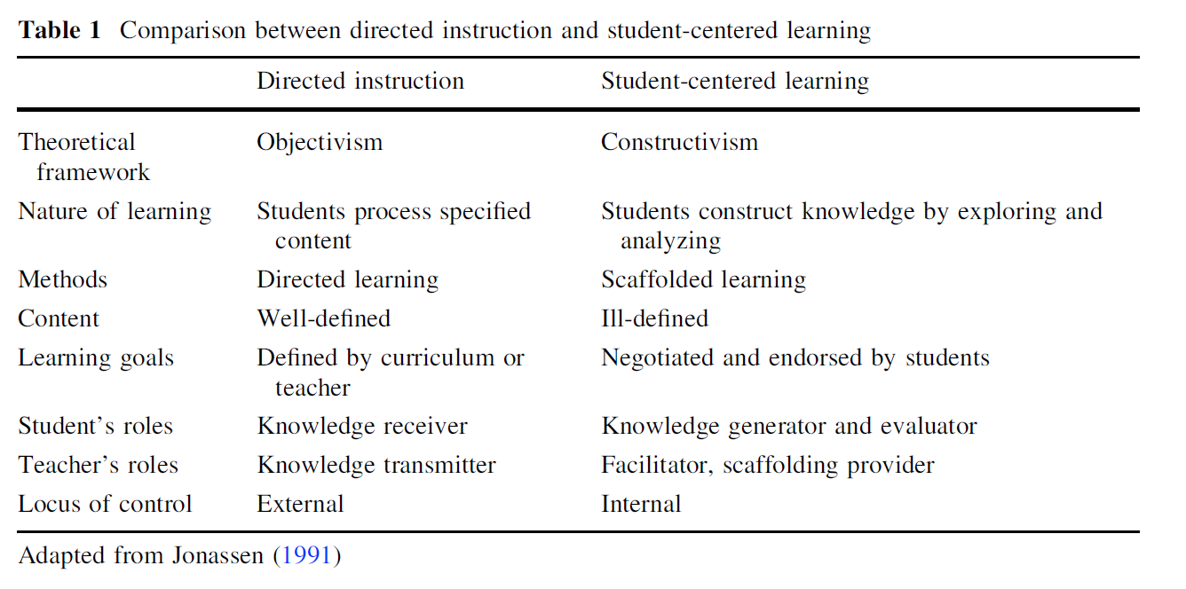 (Lee, 2016, p. 4)
Fig. 1
Another important note from the Lee article is that, “When individuals perceive autonomy, they believe their action supports their own will, choices, and self-determination (Ryan and Deci 2006).” This perceived autonomy is what worried Matusov, the notion that students may be manipulated like Rousseau describes, into following the will of the educator while never being the wiser. This semantic line between student sense of ownership and teacher perceived and real control of the classroom is not a primary goal of this paper, and in a program with a high at-risk population it is not a large factor in classroom design. Any student growth from the historically low-achieving population that Alternative Schools draw is a success, and movement towards self-determinism and career success is celebrated without questioning the sense of ownership a student has of their academic experience. The Lee paper recognizes that,
“...at-risk students, refugee youths, and English as Foreign Language students, who under-perform historically and lack background and skills to engage their learning environments (Nelson et al. 2012), present needs in managing individual learning decisions. For the range of individuals, we need to scaffold uniquely different needs in order to empower them to assume ownership for their learning.” (Lee, 2016, p. 22)
This is especially true at Phoenix, where the number of disenfranchised and underperforming students is higher than area A-1 (non-alternative) educational programs. The ownership and sense of autonomy that multiple student designed portfolio paths allow mimics the description of SCL. This perceived autonomy moves the “locus of control” from an external source (the teacher) to the student themselves.
“Autonomy has been associated with locus of control by personality theorists (e.g., Rotter 1966). When individuals perceive internal control, they believe they control events that affect their lives; the outcomes of their actions result from their own decisions and abilities. In contrast, when control is perceived as externally regulated, individuals believe they have limited influence on outcomes. They perceive future success or failure depends on external circumstances beyond their control, such as task- difficulty or luck (Rotter 1975). (Lee, 2016, p. 9)
The goal of moving the locus of control from teacher to student is to increase student sense of agency and ownership of academic outcomes not only in this course, but at large. This increase in ownership comes as a direct result of teachers giving students greater autonomy in their work, with the final the goal being students taking ownership of their own actions and behaviors. Phoenix deals with behavioral deficits daily, and most of those deficits stem from academic deficits. Students do not engage with the material because they have “learned helplessness” (Grandin, 2015, p. 27) and are unwilling to attempt anything new because they have been burned so many times in the past. SCL, Key Projects, Multiple Path assignments, and other student driven curriculum methods can reset this sense of learned helplessness by providing students with a familiar context for unfamiliar content and skills. The 1994 article, Student Directed Planning: Fostering Student Ownership in Learning, argues that, “Initially a number of varied activities are provided for students by the teacher as examples of their own future planning.” The study also suggests that “student directed planning” be used only as a “support” method of instruction and not as the primary method of instruction” (Platz, 1994, p. 3). This suggestion that Student directed planning should be ancillary to direct instruction has fallen by the wayside in light of a new push for education that allows student inquiry and interest to determine the parameters of a classroom.
“...autonomy supports two roles in SCL: sovereignty and responsibility. In terms of sovereignty, students assume the power and control to determine learning goals, decisions, and actions required to achieve those goals. When encouraged to make decisions, students perceive it as taking control of their learning and develop personal ownership. For responsibility, students become accountable for the consequences of their goals, decisions, and actions. They assume responsibility for managing their learning processes and project completion.” (Lee, 2016, p. 10)
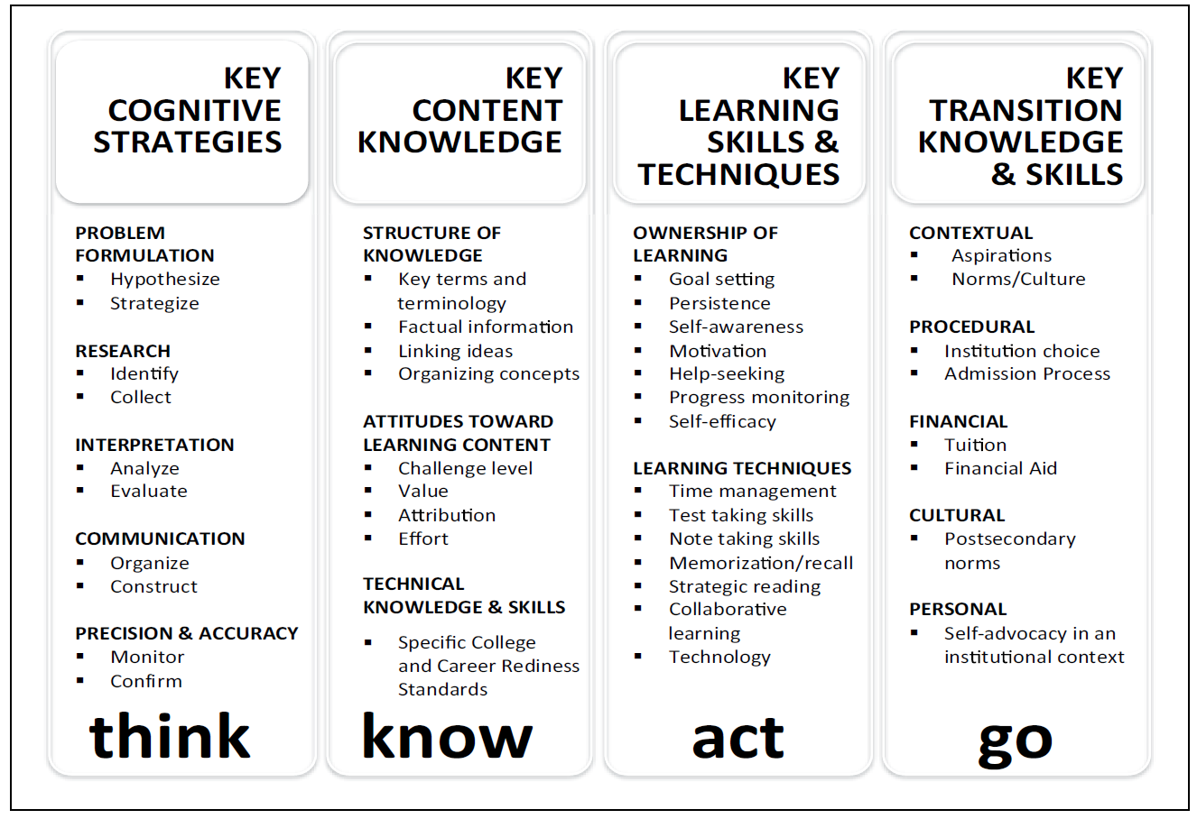
The underlying goal of this research is students as self-determining adults in their post-secondary lives. With that goal in mind, the 2014 article, Student Ownership of Learning as a Key Component of College Readiness, describes the specific strengths that student directed learning can build. The article outlines four “Keys” in its model for college readiness in the figure below,
Fig. 2
(Conley, 2014, p. 3)

In the article, the authors argue for performance based assessments of these “Key” aspects of college readiness as strong methods of building student sense of ability and minimizing fear of failure, “These performance accomplishments help to minimize individuals’ anxieties around learning and the self-efficacy that they help develop will transfer to other scenarios and enable the individual to counter anxiety from past failures (Bandura, 1977) (Conley, 2014, p. 9). This emphasis on performance-based portfolio work is mirrored in the Key Project structure of this study. Conley et. all also argue that self-reflection and metacognition are important predictors of future success in college,
“Central to the notion of taking ownership is awareness of and involvement in the learning process. This involves actively participating in the learning process and reflecting on that participation. Like the other student ownership of learning factors discussed here, metacognition and self-monitoring have relationships with outcomes such as K-12 student achievement, college student GPA, and college retention (Credé & Kuncel, 2008; Lindner & Harris, 1998; Marzano et al., 2000; Richardson et al., 2012). (Conley, 2014, p. 9)
It is this goal of greater individual freedom from negative contextual barriers like generational poverty, abuse, and incorrect or inappropriate response to deficits that drives the structure of the classroom in this study. Students at Phoenix often experience life through a lens that is the sum of their very negative life experiences, and this produces many unsuccessful outlooks on education, their ability to hold a job, and even their own sense of self-worth. The agency building aspects of the research included in this study can serve students in A-1 schools well, but in A-5 alternative programs it may return aspects of students’ humanity that have been degraded as well as improving academic outcomes.

Research Design
The structure of this study is a two-week (10 day) reflection and meta-cognitive unit on the gross structures of the course with a focus on student perception of ownership and value of specific aspects of the course.
The planning for this two-week unit is designed to reflect the different levels of complexity and freedom that aspects of the course provide. The first few days will focus on structures with less student voice and choice, and the final discussions will focus primarily on classroom elements that are designed to have the greatest amount of student control. The instruction will be built into the “end of year” festivities that our program engages in and will provide students with an opportunity to interrogate their work this year with a focus on ownership and its correlation to success in multiple areas.
Ethical standards will be upheld by attributing individual student responses to numerical values, and whenever specific student anecdotes are used, a number (Student 3, etc.) will be used to replace the student’s name. The purpose of this intervention is to determine student sense of ownership of academics during the school year, as well as to allow for meta-cognitive reflection at the end of a school year with the goal of increased ownership in the following year. Upon reviewing the information produced by this study, the classroom educator will increase the amount of meta-cognitive pieces completed throughout the following school year or keep the same level of reflective writing. This specific intervention path was chosen to most positively affect the educational outcomes of students in the Phoenix School of Discovery program, due to high rates of disenfranchisement and a general lack of ownership in educational outcomes.
This intervention plan aligns to the Common Core Standards as adopted by the Kentucky Department of Education through the writing and content production standards, as well as the focus of student production of portfolio defenses as adopted by the JCPS district due to the focus on writing production and reflection through written pieces to be included in student writing and growth portfolios.
The learning goals for students during this study are to accurately report their sense of ownership for various aspects of their 11th Grade English course, with written explanations of their reported data. The student reported data will be assessed to determine the efficacy of disparate aspects of the course in creating a sense of ownership. Outlier data will also be discussed in the context of student written responses to explore the data in the context of extreme or highly aberrant student experience.
This two-week unit specifically targets student sense of ownership through a three part metric. Students will complete a pre-test self-reporting instrument in which they assign a sense of ownership to different aspects of the course and provide light written explanations of their reasoning. This will be followed by daily discussions of the different aspects of the course that students previously reported on, and finally a post-test designed to aggregate student sense of ownership on a wider scale to more specifically determine student ownership of academic outcomes.
Technology will be used in a majority of the aspects of the classroom that students are reflecting on during this study, specifically the online learning management systems (LMS) NoRedInk and Newsela will be discussed, as well as the teacher produced portfolio pathing system at www.kingdomandkeys.com.
Students with notable writing, cognitive or behavioral needs will be provided scaffolding to allow them to respond to the written and multiple-choice aspects of this two-week unit.
The raw data, as well as, student constructed meta-cognitive responses, will be compiled into an excel sheet and then parsed through multiple avenues including: engagement tracking data (via a gamified engagement tracking system), standardized test performance (ACT English and Reading scores), current Newsela reported Lexile level, and truancy data.

Data Analysis
The data used in this study was pre-recorded during the year, as the study is a measure of student sense of ownership against multiple aspects of the course. Pre-recorded data sets are ACT English and Reading Scores, Truancy Data, Final Grade Data, Classroom Gamified Engagement Data. The goal of this data collection is to determine focus areas to modify for the next school year to increase student sense of ownership overall, and to plan a classroom that more directly correlates student sense of ownership and control to academic and behavioral successes.
The instrument used for the data collected in this study was a survey allowing students to self-report their “sense of ownership” that followed a series of questions about the value of different aspects of the course. The students then took part in a ten-day reflection unit, during which they produced anecdotal responses describing their sense of ownership and agency in different specific aspects of the course, as well as in the course as a whole.
Of the 35 students in the Junior ELA course, 32 took part in the study. The three students who were not included were suspended or truant during the majority of the study.
This data analysis section is broken down into three separate discussions. Student ownership as compared to academic outcomes (final course grade, ACT performance, and portfolio production), student ownership as compared to behavioral measures (truancy data, and engagement data), and salient student anecdotal responses from three groups of students, divided by final grade in the course.
Fig. 3
The first figure in this study (fig. 3) is base student sense of ownership data on a 10-100 scale. Important takeaways from the base ownership data are that no student self-reported feeling less than 40% ownership of the course outcomes and their work. This is particularly worth noting, as some of the highest ownership reporting students were in the bottom 50% of final grades for the course. An explicit goal of the course is teaching ownership of work through multiple path portfolio construction, which breeds agency and a sense of self-determination. The average sense of ownership score was 73%, with 23 out of the 32 students reporting they felt ownership for over 50% of their effort and experience in the classroom this year.
The outliers in this data set were five students who reported that they felt ownership of 100% of their educational outcomes, and three students who reported they felt less than 50% of their educational outcomes belonged to or represented them.
The first comparison of data sets is the “Final Grade vs. Reported Ownership” graph below. This is a comparison of highest to lowest scoring student grades with their self-reported ownership data included. While there is a slight corollary trend to the ownership data, there are many examples of stark outliers in this data set, that show students of all academic success ranges in this course can feel ownership in the course, with the two notable spikes near the end of the graph.
Fig. 4
Notable outliers from this data set are the only student to receive 100% in the course gave themselves an 80% ownership score, likely due to self-doubt or the high internal measures for success that push a student to 100% complete a course. The lowest scoring student in the course, with a 29%, scored themselves with a 40% ownership. There were no ownership scores below 40%.
There was a 17% contrast between the top and bottom of the grade book. When looking at only the students with A’s, the average sense of ownership is 85%, and when looking at only the students with D’s and U’s, the average sense of ownership is 68%. There is some correlation between student sense of ownership and academic performance in class, but due to the small sample size and a few extreme outliers, it is more useful to consider the anecdotal data students provide later in this paper to draw conclusions about student ownership of work and the academic outcomes of that ownership. The lack of strong correlation between ownership and academic outcomes in this graph are worrying and worth further discussion in the next section of this paper.
Fig. 5
The next discussion of ownership data is in contrast to student performance on the ACT. There are a few gaps in this data set, as on student did not attend the ACT testing day or make up their ACT test at a date in time to be included in this data set.
While there is some correlation in both the ACT Reading and ACT English test between higher ownership and higher test scores, there are marked outliers that bear discussion. For instance, of the students who reported 100% sense of ownership in their work this year, only one out of the five students passed the Reading test. None of the other 100% reporting students passed either the English or Reading ACT test. This is disconcerting, as much of the course is designed to build skills that will allow students to pass the ACT English and Reading exams well, and would point to the course being misaligned with ACT standards. However, of the students who passed the English test, the average reported Ownership was 76%. And students who passed the Reading test reported an average ownership score of 80%. There were few low ownership scores in the passing students. Upon reviewing this with these students, the consensus was that they felt there were aspects of the course beyond their control or ability to influence, and thus they could not claim 100% complete ownership for their academic outcomes.
Fig. 6
Fig. 7
The next data set is at the heart of this study and discusses student ownership versus “Key Project” completion. In this classroom, students are presented with ten different “paths” each consisting of a series of pass/fail rubrics designed to build employability skills that follow the theme of the students’ chosen “path.” These Key Projects are required work every two weeks, and are taken late for full credit as long as the pass/fail rubric is followed carefully. Students are tasked with making their portfolios as accurate a reflection of their goals, interests, and personalities as possible. This element of the course is designed with student ownership and agency in mind, and many of the Key Projects are submitted and designed by students, for other students.
The average number of Key Projects completed for this entire class was 15 projects, and of the five students who reported 100% ownership, the average was 16 projects. Of the five students who reported less than 60% ownership, the average Key Project completion number was 10. Two students completed 31 projects during the 24-week period the course was in session, meeting the requirements of each pass/fail rubric and expanding their portfolios with research and writing that represents their interests and career goals. Both of those hard-working students reported feeling 80% ownership of their academic outcomes.
By contrast another student completed only 10 Key Projects and felt 100% ownership of their academic outcomes. Due to the highly personal nature of the Key Project and multi-path portfolio system, it is not surprising that students with varying degrees of portfolio completion record having a stronger sense of ownership having completed more of these assignments. The correlation between Key Project completion and sense of ownership is easily the strongest indicator of an element of the course that students find value in from this metric.
For increased certainty, students were also asked to attribute a number to the value they felt aspects of the course held for them. The aspects of the course students were asked to value were: grammar, close-reading, and Key Projects. 90% of students reported valuing the time they spent working on Key Projects, while only 65% of students valued grammar, and 58% of students valued close-reading. When asked where their effort was spent, students reported that they gave Key Projects 82% of their effort, grammar 79% and 60% for close-reading. When asked what percentage of choice they felt they had in the course, students reported that they felt that the course offered 92% on a scale of “no-control” to “freedom to choose.”
The next section of this discussion will focus on behavioral data in the form of attendance and non-graded engagement points. There is almost no correlation between attendance data and student reported sense of ownership. The average days absent for students who felt they owned 100% of their academic outcomes was 26 days absent, and the average days absent for students who felt they owned less than 60% of their educational outcomes was 12 days. This data set does have a few very interesting outliers, however, in that the top five absentee students, with an average of 38 days absent, also reported their ownership at 86%, higher than the whole class average for ownership. Regardless of time out of school, these students felt a strong ownership for their work in the class. It may be worth noting that these five students had an average engagement score of 1936 XP points, which was 96% of the class average, placing them in the middle of the pack for verbal recognition of effort in the classroom.
Fig. 8
This talk of “XP” leads into the final metric student ownership was measured against, Student Engagement as measured by a classroom gamified behavioral tracking system. This system was designed to allow students to receive near constant feedback on positive behaviors and engaging with the classroom content. The structure of the system is simple, students earn two XP (experience points) for each card they are handed during the course of the class. At the end of the period, students turn in their XP to be tallied and added to the class average. The two periods with the highest average XP at the end of the week earned a group reward during the last twenty minutes of the Friday class. XP cards could be handed out for a variety of reasons, but never frivolously, and always with specific verbal praise attached to their reason for being handed out, to increase their sense of value. Common reasons for gaining XP could be: turning in your assignments with your name if that was a struggle, remaining on task without redirection, accepting redirection towards on-task behaviors, positive communication, apologizing for negative communication sincerely, completing the daily journal, etc.
All year long students compete with other classes through these points, and at the end of each trimester, their “hustle” score is included as a non-graded aspect of the grade book for bragging rights but not for a grade.
The top five engagement point students recorded an average ownership score of 88% while the bottom five engagement point students recorded an average ownership score of 62%, showing a correlation between XP earning and sense of ownership. The average score for engagement points for the class was 2017 XP (experience points) with a few notable outliers. All three of the lowest ownership scoring students were in the bottom 30% of engagement point earning students and the lowest scoring student, with 394 points, recorded a high ownership score of 80%.
Fig. 9
A correlation between XP earning and ownership is understandable, as student ownership in Alternative programs in large part stems from relationship building. As Ruby Payne writes, “First and foremost, create relationships of mutual respect with students. Mutual respect is not about being their friend or their buddy but rather about having high expectations, insistence, and support. Virtually all learning occurs within the context of a relationship (Greenspan, 1997; Goleman, 2006; Comer, 1995)” (Payne, 2009, p. 4). Every two XP points a student has received is indicative of specific verbal praise, often in front of peers. This is a highly valuable commodity for students who have historically failed in formal school settings, and high student engagement with this system is similarly likely to build a sense of ownership to the Key Project multiple pathed portfolio structure. The control is in the students’ hands, and it is up to them to present the teacher with their goals, their means, and their efforts on their terms.
The final piece of data collected is a short collection of aggregated student feedback explaining their “why” for their ownership scores. Student responses will be broken into four categories: the 100%, 80%, 50-60%, and under 50% ownership.
Four 100% ownership quotes:
Student 19 reports that, “I feel like this class gives us a lot of ownership. Like we get to choose our Key Projects.” Student 19 had joined the class later in the year, and had only completed 16 Key Projects, but had completed the course with a 93% final grade. Student 19 was also the 3rd highest scorer in engagement points.
Student 23 reported the reason they felt 100% ownership was that, “I was allowed to use my own creativity.” By the end of the year, this student had completed 23 Key Projects, and ended the year with a 98% final grade.
Student 12 reported, “We got to do whatever station we wanted to,” as the reason they felt the highest possible ownership. This student completed 17 Key Projects and ended the year with a 93% in the course, but their written reasoning is referring to the student driven station structure that the class ran from Monday through Thursday each week, which was also implemented to improve student sense of control, agency, and ownership.
Student 20 reported their reasoning for a sense of ownership was, “because I have a car.” This student did not pass the course and was absent more than fifty days while pursuing drug abuse rehabilitation. When the student was present, they pushed hard to complete the work and earned 1304 XP points in the engagement tracker, managing to complete 10 Key Projects as well.
Three 80% ownership quotes:
Student 32 defended their ownership score by writing, “I did the work, I came up with the ideas, therefore they are mine. But I did get some help with Grammar, so it wasn't entirely mine. / Yes, through my work I do and the effort I put into that work.” This student was a highly prolific writer, and completed 31 Key Projects, creating a highly personalized portfolio. The student ended the year with a 100% final grade.
Student 5 wrote, “Yes, because I take responsibility for my grades, behaviors and actions / I have a 4.0 GPA, and I have turned in all my work, and I have great self-control.” This student was also a prolific writer, and produced 30 Key Projects for the course, ending the year with a 99% final grade. Both student 5 and 32 topped the class in Key Project production but were reticent to claim 100% of the ownership for their experience in the room. This is likely because, as student 32 pointed out, there are some aspects of the class that are still direct-instruction like grammar and close-reading and are led by an outside educator.
Student 24 wrote, “I still blame others, but I’ve gotten better about being honest with myself.” This student was “owning” a score of 64% and the single Key Project they had completed alongside much end of course make-up work. Ownership, in the case of Phoenix, is not always going to correlate with successful academics, but should be a primary goal. Students who understand and recognize their own part in a low grade, as well as the means to improve it, are empowered entering the next school year to engage more successfully with the content.
Two 50-60% ownership Quotes:
Student 15 wrote, “You do not own your own education simply because you do not choose what you need. Education is based initially on a standard made to force general knowledge on minors. This often makes them hate education and not want to continue to a point in which they can choose / While I have done the work, a lot of it felt like I had to more than "I wanted to" it feels less influenced of my own accord.” As you can hear, this student is a natural thinker, and if not for the late move to Phoenix coupled with 20 days absence, they would likely have felt greater ownership of their work. As it stood, they completed 10 Key Projects with a final grade of 83% in the course.
Student 4 responded to the question about why they feel ownership by writing, “But I feel like I dropped to a "20%" during the year at times.” This student struggled to stay on task during the year and completed 10 Key Projects with a final grade of 60%.
Student 17 wrote, “I personal[ly] believe I own my education in a sense. I say yes to that because of you being in control of what you do, how you do it, even if you do it. So yes. You do own your education (on that note though) You (in college especially) choose what classes you do and whether or not you do it.” This student only completed 8 Key Projects, and finished the course with an 84% final grade.
Three <50% ownership quotes:
Student 11 wrote, “I liked the choices, but I hate writing.” With 11 Key Projects and 18 days absent, student 11 is only slightly below average in other areas of interaction in the classroom. Student 11 struggled with defiant behavior and would often respond combatively when redirected by the ECE dedicated co-teacher.
Student 21 wrote, “[I own] everything / I slacked.” Despite feeling like a slacker, student 21 completed 20 Key Projects and finished the course with a final grade of 65%. This student also struggles with chronic depression, as do many students at Phoenix, and is particularly vocal about their feelings, despite producing many impressive portfolio projects.
Student 14 wrote, “I do my own thing.” This student is a recent transplant from a more heavily behavioral program and has been non-responsive the majority of the time when being re-directed, choosing rather to watch videos or play games instead of completing work. The student completed 3 Key Projects and had a final grade of 29%.
These student write-ups are useful framing tools for the raw quantitative data above, especially in that the data represents a sense of ownership which can be applied to positive or negative academic outcomes. Some students are beginning to claim their negative academic outcomes for the first time, and others are recognizing that they have personal career goals that can be met through the multi-path portfolio structure of the course, and are beginning to feel more ownership through the deepened sense of agency.

Reflection of Study and Action Plan
The greatest positive takeaway from this study in terms of impact for the classroom in question is that students with high self-reported ownership are also students who are highly engaged as measured by the gamified XP system, and they are students who regularly self-assign and complete the Key Project portfolio pieces. Students derive their sense of ownership from their portfolio projects and from the engagement and verbal feedback that the XP engagement tracking system provide.
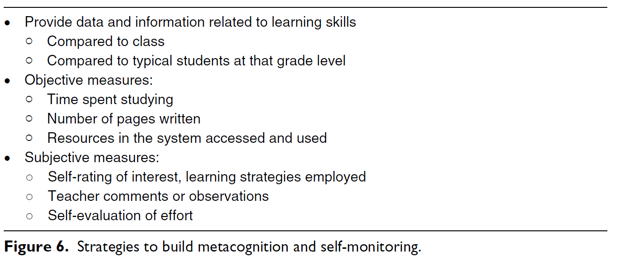
The lack of correlation in other areas are just as interesting. Student truancy has almost no effect on student sense of ownership. This is likely not only an outcome of this single classroom, but a program wide emphasis on making students who are chronically truant feel welcomed whenever they are in the building and working to catch students up through alternative assignments and skill measures. Student academic achievement through the ACT English and Reading tests remains separate from student sense of ownership, as well as the rest of the course metrics. As an A-5 Alternative Program, Phoenix’s primary purpose is to keep at-risk students from dropping out or failing to complete high school. Standardized testing is a goal of my classroom, but it is ancillary to the goal of improved self-determinism, and a working portfolio that contains skills that improve student employability.
Fig. 12
The structure of the classroom described in this paper responds to the questions posed by Philip Williams in his 2017 article, Student Agency for Powerful Learning,
“How much are we listening to student voice, being responsive to student voice, and, most importantly, enabling student voice that leads to action? Are the structures, procedures, rules, and guidelines we hold onto so dearly enhancing students’ personal integrity, or are we more interested in reaffirming our authority?” (Williams, 2017, p. 5)
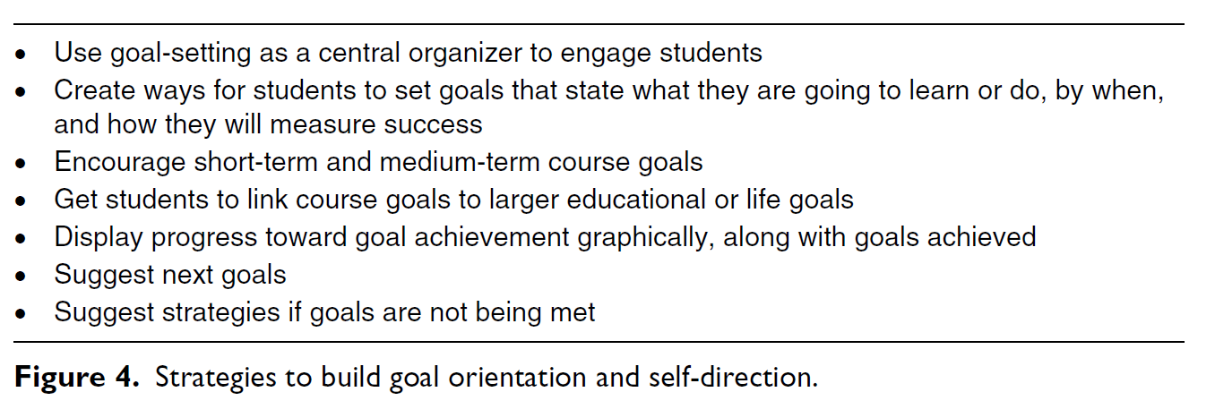
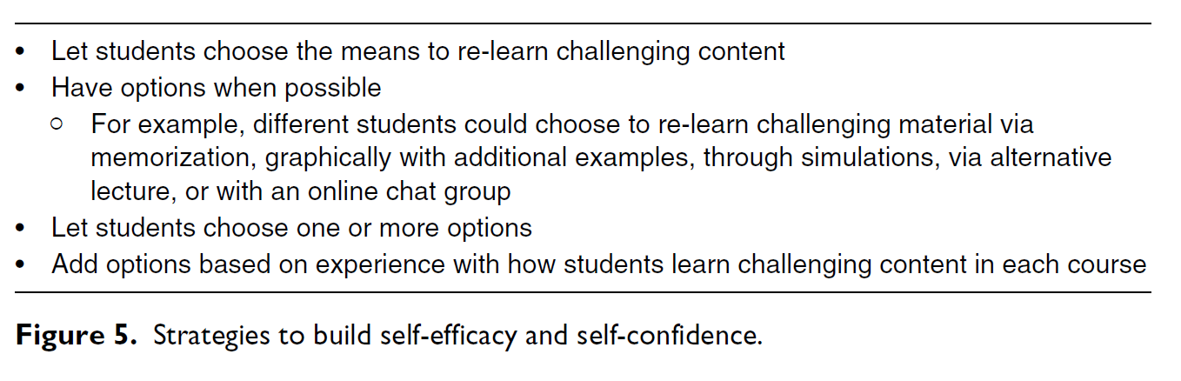
Students in this study feel ownership when they are receiving targeted positive feedback for right actions. As in the 1992 article on Purposeful Behavior, these students are responding to external stimulus that feeds their need for “narrative control,” (Cziko, 1992, p. 4) they are hungry to tell their own story and have what Matuzov called “authorial agency” (Matusov, 2015, p. 15). It is almost a program requirement that the ACT be a secondary goal for our students after behavioral and academic remediation, but this does not mean that Phoenix students are not planning to go to post-secondary educational experiences. Students commonly plan to attend undergraduate programs and trade schools out of Phoenix, and to that end the goal of increasing student ownership and agency is of high importance.
Fig. 10
Fig. 11
The 2014 Conley study on college readiness provides a strong defense of multi-pathed student-designed portfolios that focus on employability skills with a single figure, arguing that pushing students to “link course goals to larger educational or life goals,” and calls for teachers to “have options when possible, for example, different students could choose to re-learn challenging material via memorization, graphically with additional examples, through simulations, via alternative lecture, or with an online chat group,” a diverse collection of differentiated skill measures, which is precisely what the Key Project system is designed to function as (Conley, 2014, p. 9).
According to Conley, “performance accomplishments” like “portfolio additions” can build a students’ self-direction as well as provide a goal orientation that will drive them towards a career path. While the Key Project structure was designed to improve student agency and sense of ownership, this study was designed also as a meta-cognitive reflection on the Key Project, and XP engagement tracking aspects of the Junior year ELA classroom. The Conley study argues that, “metacognition and self-monitoring have relationships with outcomes such as K-12 student achievement, college student GPA, and college retention” (Conley, 2014, p. 9).
In fact, the structure of the study, that students would self-evaluate as well as be provided with other students’ engagement data via the gamified engagement XP tracker, mimics the findings of that 2014 study in strategies for building metacognition and self-monitoring in students (Conley, 2014, p. 11).
The Key Project system and XP engagement tracking system produce a sense of ownership in students, and self-reported student ownership is unaffected by truancy. These are positive takeaways about the classroom structure as interrogated by student responses. However, the lack of correlation between ACT scores, final grades and ownership is worrying despite the Alternative School mandate of graduation over testing. The Phoenix school has improved its English and Reading ACT scores from the last school year but increasing student sense of agency in the skills that those tests measure may have a positive effect on future testing. It is worth investigating in the future methods of connecting existing positive structures (Key Projects and Gamified XP tracker) to more formal ACT skill building tools that the program uses like NoRedInk or Newsela.
This study has highlighted the complex relationships students in an alternative setting may have with the idea of ownership, with some students attributing ownership to their low scores or output as an example of their lack of ability or work ethic, and other students attributing ownership to their own work output. Some students even curtail their own sense of ownership to avoid including any external assistance rendered by the educator. For future ownership studies at The Phoenix School of Discovery, a more specific instrument that targets agency and ownership separately will likely produce data that is more easily parsed. It is this author’s firm belief that student agency is the root of successful alternative school pedagogy in that it directly recognizes each student as a Freirean “Subject” who pursues their own goals within the construct of the classroom. JCPS is moving to adopt student “digital backpacks” beginning next year, with an emphasis on student produced portfolio defenses and highly personalized portfolio pathing for the entire district. This study reflects those goals and has highlighted the importance of choice for alternative students to feel a sense of ownership, regardless of what the district at large pursues in the future.

References
Biddulph, M. (2011). Articulating student voice and facilitating curriculum agency. The Curriculum Journal, 381-399.
Cziko, G. A. (1992). Purposeful Behavior as the Control of Perception: Implications for Educational Research. Educational Researcher, 18-27.
David T. Conley, E. M. (2014). Student Ownership of Learning as a Key Component of College Readiness. American Behavioral Scientist, 1018-1034.
Equity Scorecard Team. (2013). Envision Equity: A community commitment to improving education for all students. Department of Diversity, Equity and Poverty, 1-22.
Eugense Matusov, K. v. (2016). Mapping Concepts of Agency in Educational Contexts. Integr Psych Behav, 420-446.
Eunbae Lee, M. J. (2016). A design framework for enhancing engagement in student-centered learning: own it, learn it, and share it. Education Tech Research Dev, 707-734.
Freire, P. (1969). Pedagogy of the Oppressed. NY: The Continuum International Publishing Group Inc.
Hao Lei, Y. C. (2018). RELATIONSHIPS BETWEEN STUDENT ENGAGEMENT AND ACADEMIC ACHIEVEMENT: A META_ANALYSIS. Social Behavior and Personality, 517-528.
Paula E. Chan, M. K.-D. (2014). Beyond Involvement: Promoting Student Ownership of Learning in Classrooms. Intervention in School and Clinic, 105-113.
Payne, R. K. (2009). How the Environment of Poverty (Having Fewer Resources) Impacts Cognition and Learning. 1-7.
Platz, D. L. (1994). Student Directed Planning: Fostering Student Ownership in Learning. Education, 420-423.
Shari Tishman, E. P. (2017). Building Students' Sense of Agency. Educational Leadership, 58-62.
Temple Grandin, D. M. (2016). The Loving Push. Future Horizons.
Williams, P. (2017). Student Agency for Powerful Learning. Knowledge Quest, 9-15.

